

Foundations of Programming

Assignment No.: 22
PROBLEM STATEMENT: Write a menu driven program in C to perform various string operations using in-built functions.

OBJECTIVE:

- To understand the concept of strings in the C programming language.
- To learn how to use built-in string functions for string manipulation.
- To perform operations such as length calculation, copying, concatenation, comparison, and reversal using menu options.
.

THEORY:
In the C programming language, a string is a sequence of characters terminated by a null character ('\0'). Strings are stored in character arrays and manipulated using functions available in the string.h header file.
Common built-in string functions include strlen() for finding the length of a string, strcpy() for copying one string to another, strcat() for concatenating two strings, and strcmp() for comparing two strings.
A menu driven program allows the user to select different operations from a list of options. Based on the user’s choice, the corresponding string function is executed. This approach makes the program interactive and easy to use.

PLATFORM: Linux

INPUT: Two strings entered by the user.

OUTPUT: Displays results of different string operations such as length, copy, concatenation, and comparison.

CODE:
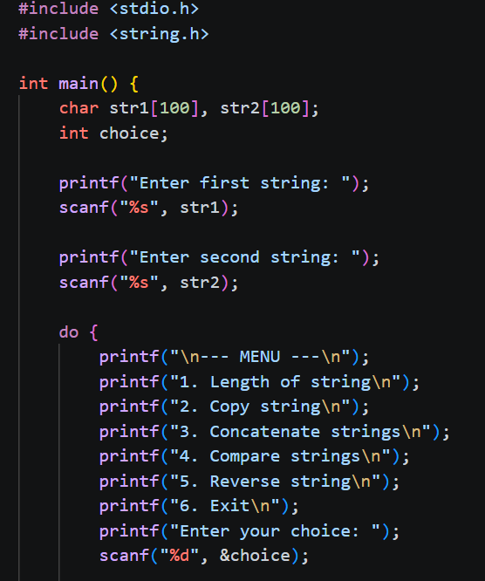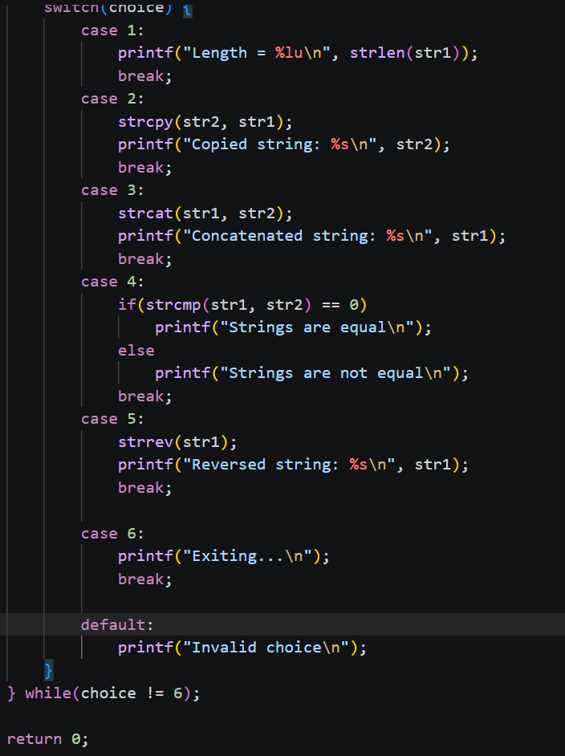

SAMPLE INPUT:
Enter first string: Hello
Enter second string: World
Choice: 3

SAMPLE OUTPUT:
Concatenated string: HelloWorld
CONCLUSION: Thus, the C program successfully demonstrates different string operations using built-in functions through a menu driven approach, making the program interactive and easy to use.

FAQs:
- What are built-in string functions in C and why are they used?
Soln: Built-in string functions in C are predefined functions provided in the <string.h> header file to perform common string operations. They are used to simplify tasks like finding length (strlen()), copying (strcpy()), concatenating (strcat()), and comparing (strcmp()) strings. These functions save time, reduce code complexity, and make programs more efficient and readable.

- What is the purpose of the string.h header file in C programs?
Soln: The <string.h> header file in C provides declarations for built-in string handling functions. It allows programmers to perform operations like calculating length, copying, concatenating, comparing, and searching strings using functions such as strlen(), strcpy(), strcat(), strcmp(), and strstr().
- How does a menu driven program improve user interaction in programming?
Soln: A menu-driven program improves user interaction by providing a clear list of options for different operations, allowing users to choose what they want to perform. It makes the program easy to use, organized, and interactive, as users can repeatedly select tasks without restarting the program. This enhances usability and makes the program more user-friendly.

